SUPPLEMENTARY FIGURES

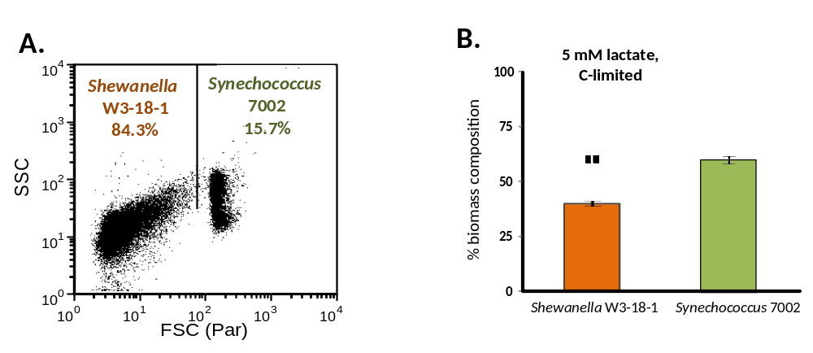
FIG. S1. Flow cytometry analysis of the Synechococcus 7002-Shewanella W3-18-1 co-culture during carbon-limited growth at 1720 µEin•m⁻²•s⁻¹ with 5 mM lactate as the sole source of carbon. (A) The ratio of Synechococcus 7002 and Shewanella W3-18-1 populations within the co-culture were identified from 50,000 recorded cells using size (FSC) and complexity (SSC). (B). The relative biomass composition of the co-culture was calculated using the equation using, , where , are the cell volumes of each organism and , are the measured population ratios. Cell volume calculations for each organism were carried out using scanning confocal micrographs. Shewanella W3-18-1 was visualized by acridine orange staining, while Synechococcus 7002 was visualized by phycocyanin auto-fluorescence. For volume calculations, we used the equation V=, where a is the diameter of the minor axis, and b is the diameter of the major axis.

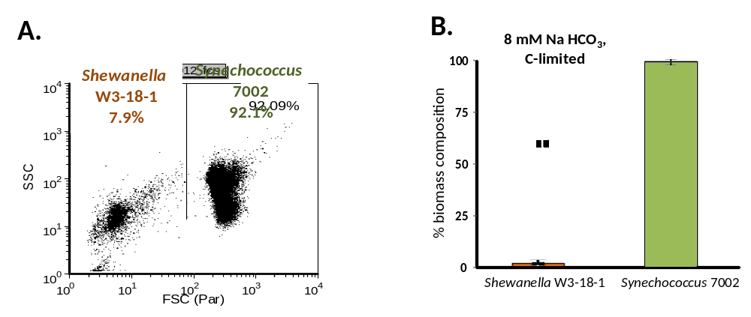
FIG. S2. Flow cytometry analysis of the Synechococcus 7002-Shewanella W3-18-1 co-culture during carbon-limited growth at 1720 µEin•m⁻²•s⁻¹ with 8 mM NaHCO₃ as the sole source of carbon. (A) The ratio of Synechococcus 7002 and Shewanella W3-18-1 populations within the co-culture were identified from 50,000 recorded cells using size (FSC) and complexity (SSC). (B). The relative biomass composition of the co-culture was calculated using the equation using, , where , are the cell volumes of each organism and , are the measured population ratios. Cell volume calculations for each organism were carried out using scanning confocal micrographs. Shewanella W3-18-1 was visualized by acridine orange staining, while Synechococcus 7002 was visualized by phycocyanin auto-fluorescence. For volume calculations, we used the equation V=, where a is the diameter of the minor axis, and b is the diameter of the major axis.

